Academy Of Natural Sciences Closing – What Can I Do?
First of all, don’t mourn – organize!
This story is not over yet, and you can help change the ending.
OK, but what concretely can I do?
Lots! Below (and on the back of this sheet) are some ideas. Most importantly, we need to make our political leaders aware of what we want to see happen (or don’t want to see happen), and dial up pressure for them to play a leadership, coordinating and possibly a financial role in crafting the solution we want to see.
Ready?
The message: The Academy of Natural Sciences has been a fixture of Philadelphia civic and scientific life for over 200 years, and holds a priceless and irreplaceable collection of 19 million specimens that continue to teach us today about our natural world. To lose the collection, and the ongoing science related to the collection, would be a tragedy. To lose the public-facing museum, however, would also be a tragedy – how many Philadelphians remember being awed by first seeing the dinosaur skeletons, either on a school trip or on a visit with family? How many young people grew up to be scientists because they regularly spent time at the Academy? Moreover, although the building needs to be renovated, the Academy belongs with the other museums on the Parkway. Do you want to see another high end hotel, luxury apartments, or worse, an empty building next to the Franklin Institute? I don’t. We already have the Family Court building across Logan Circle sitting empty for years. If Philadelphia can move the Barnes, we can save the Academy.
In contacting people, let them know what your own connection to the Academy has been and why it is important to you.
Action!
You don’t have to do all of these, but please, please, commit to at least doing one. You may find it so satisfying to have someone actually pick up the phone, that you are motivated to do more
- There is a rally on Tuesday September 8th. Spread the word, attend, and invite along or encourage your community members to attend too. 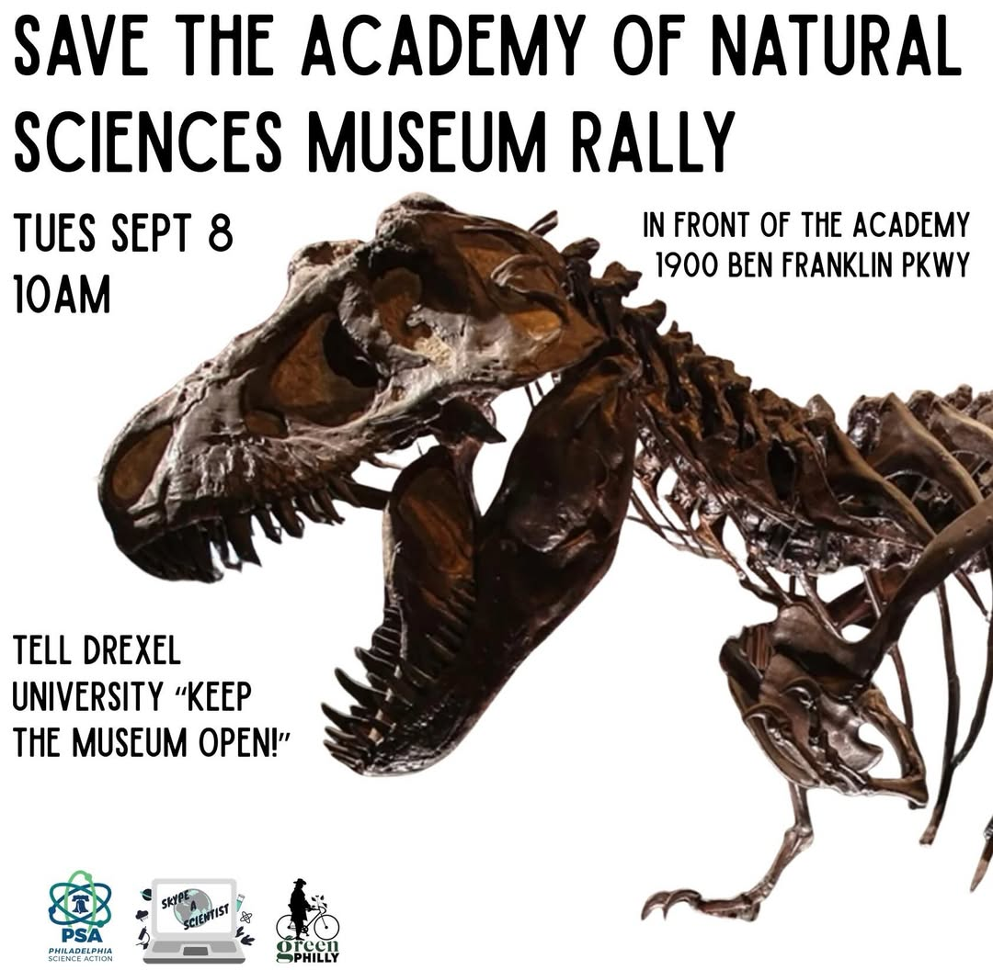
- Contact the Mayor Parker’s office, and express your views: Phone number is (215) 686-2181; you can submit a written comment here: https://www.phila.gov/departments/mayor/mayors-correspondence-form/; or on social media: @phillymayor
- Contact your City Council person, and express your views. You can also call the At-Large City Council folks, who represent all Philadelphia residents. You can find contact information for City Council at: https://phlcouncil.com/council-members/ Ask council members to pressure the Mayor to take a stronger role on finding a solution that keeps the Academy fiscally sound, on the Parkway, and open to city school children.
- Contact your State Representative and State Senator: These folks could help bring additional pressure on the Governor to intervene, and could also potentially introduce legislation to help fund our underfunded arts and culture institutions, including the Academy. If you don’t know who these folks are, use this tool to find out: https://www.palegis.us/find-my-legislator
- Contact Governor Shapiro’s office: You can contact the Governor by phone (717-787-2500, text (717-788-8990, or mail: Governor Josh Shapiro, 501 North 3rd Street, 508 Main Capitol Building, Harrisburg, PA 17120. Ask the Governor to play a stronger and more public leadership role in finding a sustainable funding solution for the Academy. Maybe point out that other states, like very purple North Carolina, actually provides public funding to its Natural History Museum. Why don’t we?
- Write to the Office of the President (President Merlo) at Drexel: president@drexel.edu Express your deep disappointment with Drexel’s decision to close the Academy’s museum, and ask Drexel to reconsider. Be polite – there is way too much bad behavior in all realms these days, and would you want his job? If you happen to be a Drexel grad, mention that!
- If you have kids who are sad at losing the Academy: Give them some agency also - suggest that they write a short letter, and/or draw a picture expressing what the Academy means to them, and sent it to either the Mayor or Governor or both. Better still, maybe your classroom teacher can have the whole class do that! Mayor Parker was a teacher once upon a time, and the Governor was/is an Academy member and brought his kids to the Academy, so don’t underestimate the impact of the kids.
- Talk to your friends and neighbors. The Sept 1 announcement of the Academy’s closing to the public came during a late-summer transition week when many Philadelphians are not paying much attention to the news. Make sure your friends and neighbors know what is going on, and tell them what you have done thus far to take action. If they want to do something, help make that easier for them by passing on information.
- Visit, and say thank you to staff. As of now, the Academy is officially closing on Sept 27th. Many staff are losing their jobs. Meantime, they are valiantly trying to do what they have always done: passionately caring for the museum and its collection, welcoming, engaging, inspiring, and protecting the public, and educating us about the wonders of the natural world. They deserve all respect and thanks, and we hope we can change the current situation for their sake as well.

Thanks for taking action!

